**Meenakshi Shiksha Samiti**

**A Project Report**

Submitted in partial fulfilment of the requirements for the award of degree of

**B TECH (CSE)**

**

**LOVELY PROFESSIONAL UNIVERSITY PHAGWARA PUNJAB**

**From 01/June/2022 to 01/07/2022**

Submitted By:

**Name**

Registration Number: **reg**

Signature :

Student Declaration

**To whom so ever it may concern**

**I,Name , reg** hereby declare that the work done by me .

On **“Content Formulation, Video Making, Data and Report Making Of Social Event”**

From **01/June/2022 to 01/July/2022**, is record of original work for the partial fulfillment of the requirements for the awards of degree.

Signature of student

Letterpad of organisation

Certificatee of appreciation

**ACKNOWLEDGEMENT**

I cannot express enough thanks to my committee for their continued support and encouragement. I offer my sincere appreciation for the learning opportunities provided by my committee.

My completion of this certification course could not have been accomplished without the support of my friend, senior and my classmates.

Thank you for allowing me to take part to experience something from you to research and write. You deserve a trip to destination visit plan! Thanks to my parent and all my close friends who I did it complete by all the precious means. The timeless count that you gave to do it possible will not be forgotten. Ultimately, to my loving, caring and all the supportive friends and classmates who resourcefully supported me.

My Deepest gratitude and love to all the ones who gave the countless time with the kind attention. It was a great comfort and relief to know that what you were willing to provide while I completed my work. My warm-hearted thanks to all the ones.

**Introduction of our NGO’s:**

**1st Meenakshi Shiksha Samiti:**

A non-governmental organization (NGO) is a non-profit group that functions independently of any government NGOs, sometimes called civil societies, are organized on community, national and international levels to serve a social or political goal such as humanitarian causes or the environment.

**Meenakshi shiksha samiti is a committee of men ,women and young children and students who** come from all walks of life with the motto of being the change they want to see in the society in terms of education and all. The biggest problem our country faces is the presence of too many people discussing issues but few trying to find solutions. Where we understand that finding loopholes are important, we believe every small action gets counted and it is important that we give away the complaints and try to do things for a brighter tomorrow.

If we want our democracy to work, it becomes extremely important that civil society is responsible and actively involved because when we get to choose the government, we become a part of it and as has been rightly said, with great power comes great responsibilities.

**Our committee has moto to help every person and society**. Work for only society development. Like food distribution, copies pencil pen or study material distribution for children, or many mor things help for society development and encouragement of youth to do something for their nation.

NGO activities include, but are not limited to, environmental, social, advocacy and human rights works. They can work to promote social or political change on a broad scale or very locally. NGO play a critical part in developing society, improving communities, and promoting citizen participation.

**DEFINITION:**

A non-governmental organization (NGO) is a group of people from different countries acting together, but not connected with the government of any country. Usually non-governmental organizations are nonprofit - that is, they are trying to do something other than make money for the people who run them.

**AIM AND OBJECTIVES:**

Aims and Objectives of our Society are:

• To provide Social, Educational and Economic Empowerment to Women and Children.

• To safeguard the rights of the Child and provide for the well-being of Children in need, more particularly,

a. Children exposed to any form of abuse,

b. Children deprived of education

c. Children suffering from ill health, physical and mental.

• To identify the beggars and impress upon them the significance of dignified living and persuade them to take up an alternative livelihood and to take such measures so as to equip them in attaining such means of living.

• To provide medical and legal aid and assistance to the old aged and to take such other Measure to ensure their social wellbeing.

•To help each and every needy at time of covid-19 and to discuss facts among them.

Objective Of Our NGO:

*The objective of the true NGO, the non-governmental organisation should be the social as well as economic welfare. The objective of the NGO should be to provide education to the children so that their society should develop with modern thinking and also help the economy of the country with good GDP. The Kalighat Trust is the great NGO of India who objects at providing educational facilities to all. They mainly work to bring the rural and the urban people together for a better society. The helps the rural people by the Akal Academies which is providing lowcost education to them. The Meenakshi shiksha samitiis child sponsoring organisation who have helped many poor and unprivileged children to come ahead. They are educating 70000 students per year in the Akal Academies out of which 28052 are free/aided. They donate for the provision of education to all and also to provide facilities to them. The Akal Academies renders value-based education to the students which makes them more capable to br in society with a good name. They are taught all the spiritual values which are needed to be a respected person. Knowing the importance of values, they always maintained the balance between the modern scientific education and the spiritual values. When the person gets proper education, awareness is created among them, they started thinking and also the sense of questioning arose in them. This had led to the development of the economy as well. With education, employment increased in the society with which the income of the society also showed remarkable changes. With the improvement in the income, people started spending more on them, they started spending on their lifestyle, particularly on their health.*

***Scope of the our Meenakshi Shiksha Samiti:***

The scope of is to develop the society, to help every people more and more and more. and for poor people distribute food .and children are also developed in every society. All children are educated. On-Government Organizations are the non-profit voluntary groups established at local, national or international level. They perform different tasks for solving problems and development of society. NGOs are connected with government or private sector firms. They deal with some social issues like women empowerment, girl child, gender issues, education, pollution, street children, slum dwellers, health, urban development, human rights, concerns of less privileged etc. NGOs bring up people's concerns and issues to the government and policy makers non-profit making, voluntary, service oriented/development oriented organization, either for the benefit of members or of other members of the population. It is an organization of private individuals who believe in definite basic social principles and who structure their activities to bring about development to communities that they are servicing. An independent, democratic, non-sectarian people’s organizations working for the empowerment of. As a result, development of courses in the nonprofit stream had also taken a back seat. However, now the scene is entirely different. Government policies, work of the existing NGOs and the media have a lot to do with bringing Nonprofit management . nto a normal career option.

MISSION STATEMENT:

1. Education, research and training

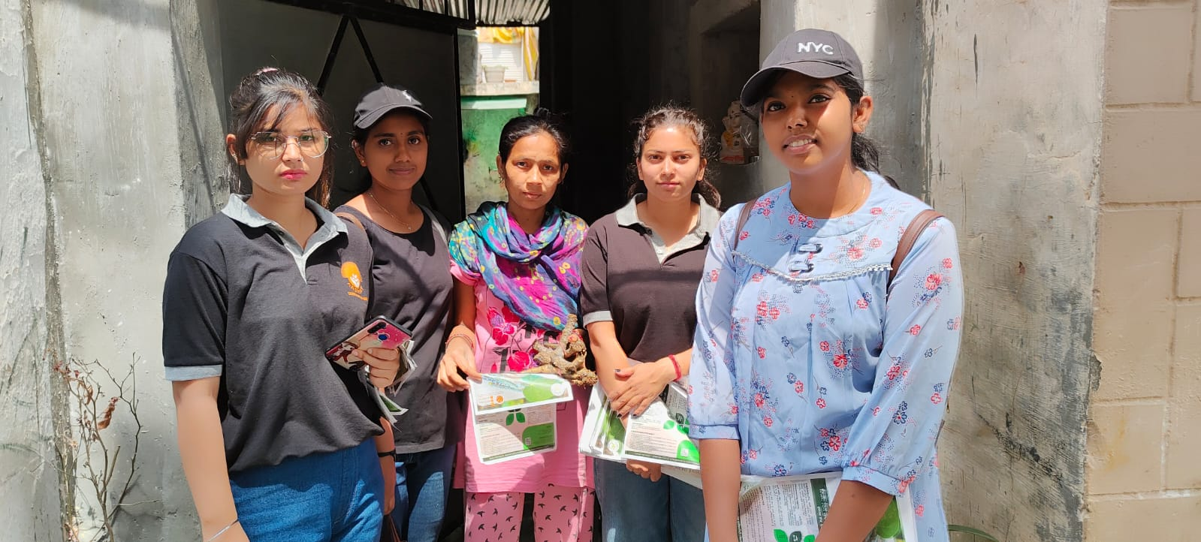

• To promote education, especially education for girl child and women.

• To conduct educational, environmental and sociological studies

. • To promote use of Information & Communication Technology (ICT) for socioeconomic development of the community.

• To organize training and refresher programs for the volunteers and officials of different Non-government Organizations to strengthen the development skills of trainees through IEC (information, education and communication) which they can use in the development sector.

• To disseminate information and knowledge, to edit, publish, and print literature and documents and to organize seminars/ conference/meetings etc.

2.Health

Health care units and blood donation unit under leadership of Meenakshi shiksha samiti and BTSM

• To spread awareness about STD and HIV/AIDS and work for the welfare of people living with HIV/AIDS. • To work in the field of reproductive and child health services with emphasis on vaccination

. • To create awareness about communicable and vector-borne disease control measures through better hygiene and sanitation.

• To narrow the difference between the health status of people on the basis of gender and create awareness against female feticide.

• To create awareness against drug menace.

• To encourage organ donation.

3.Social welfare

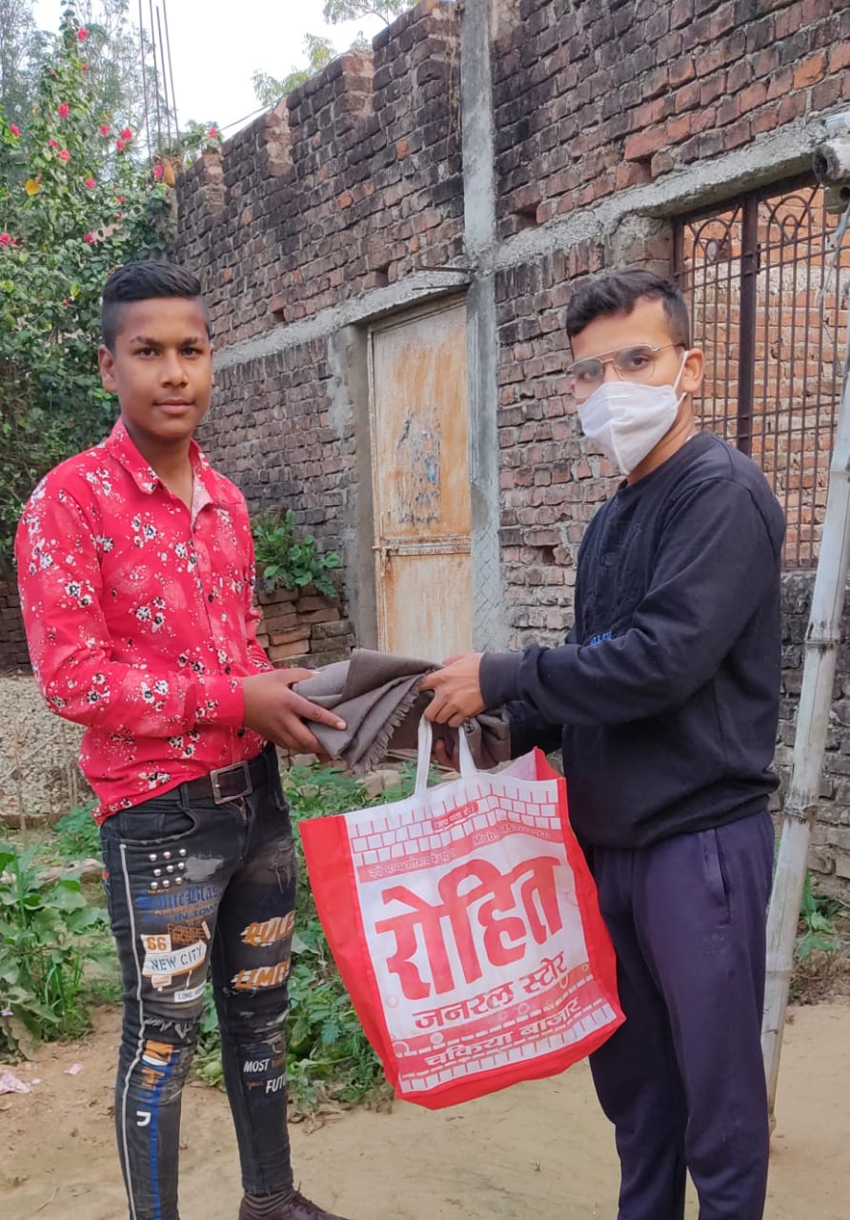

•To promote social welfare activities with special emphasis on women empowerment.

• To work for the betterment of women, children, senior citizens, and disabled and to fight against social wrongs like discrimination and harassment based on gender etc. with a vision of social justice.

•To eliminate child labour, child trafficking, and child abuse and focus on the education and resettlement of these deprived children.

•To fight against corruption and make people aware about their legal and consumer rights.

• Environment: •To work for environmental awareness, sustainable development and participative management of local natural resources for village level development. •Forestation. •To create awareness about disaster management.

Current Problem In Society:

After doing so much work in welfare of our society we are still lacking to find out solution of some major proble that arises at this particular time of covid-19.

These problems include:

1. Lacking complete knowledge among people regarding the disease
2. People of lower class being panicked and lots of anxiety is there
3. Increase Unemployment among youth and less availability of food for poor people
4. People being unaware about the risk and importance of mask
5. People unable to find beds and other resources to help others and themselves get helped.
6. Black hording in Indian markets

Now, there two situation arises one of thinking what to do and other is to find the solution of these problem and we and our organization start following second step

and start identifying the problem and working in the p[positive approach.

Main Target—Objective to be achieved:::

We have categorized our objective in that way so that our goals can be achieve in a easy way.

We start with spreading awareness among all class of people so that they at least know about the situation and prevent themselves from taking any step that can be hazardous to their life.

Secondly to fulfill the needs of needy we start donating foods on daily basis with all precaution and safety measure door to door so that everyone can be safe.

We will start a campaign of distributing masks among people and all so that they should understand the need for the mask and talk to local authority to make use of masks compulsory

At last we will try to encourage the people or corona warrior as sanitary worker and cleaner , doctors, and many because of whom we are safe today.

Steps taken to achieve target:

Our first objective is to spread knowledge in order to do so we used all possible technique as:

As we know that now a days people are more adhered to social media, so we try to spread awareness with the means of the website names:

[WWW.Jitegabhara.Com](http://WWW.Jitegabhara.Com)

Which provide various features other than spreading awareness

We choose the theme to be patriotic so that more and more people can be invoked.

Our website feature include :

Info regarding disease

Directs to cowin website in order to book slot

Prevents black hording , Provide leads so that people can be helped

In parallel with the creation of the website we start spreading awareness in offline manner also by going door to door.

**Second step** is to help the needy who are unable to get food for this we start arranging funds so that we can arrange food for them.

We on the daily basis started providing foods to them with a moto

”No One Will Sleep Hungry, God Is There”

We make food ourself at a particular place and then start distributing in a vehicle and this task thrives us crazy. We are very thankful to the sponsors wo come in front to help others.

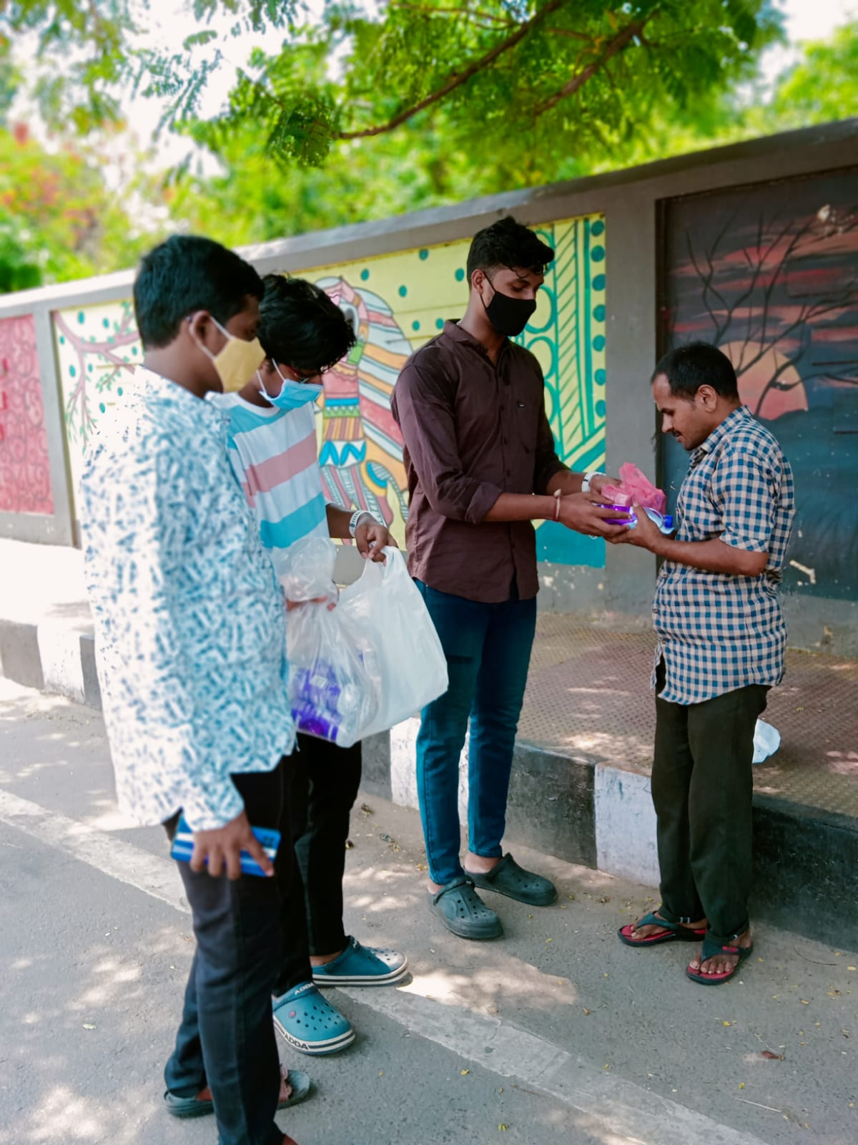 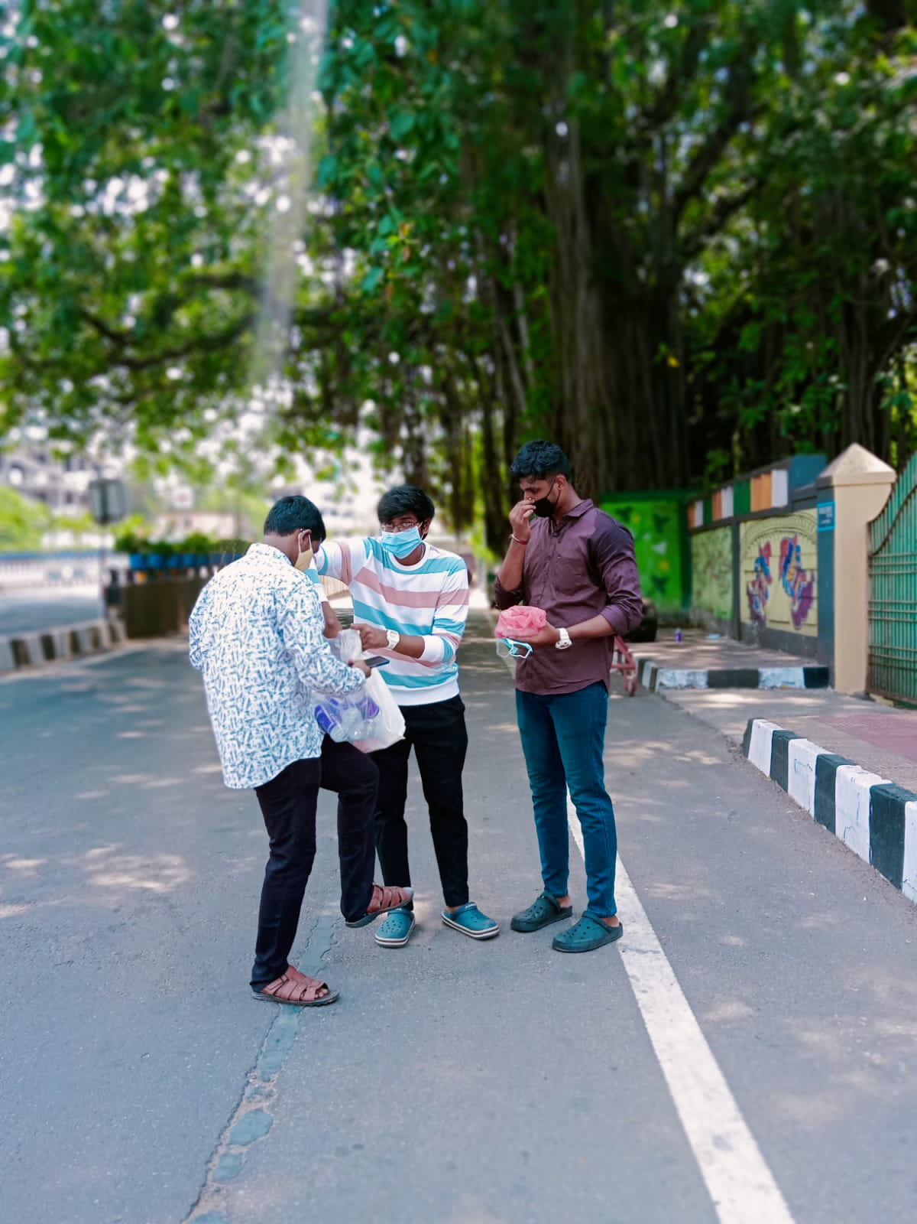

One of our sponsor and active member of Bhartiya janta Party Comes daily to help us.

We also collaborated with other Ngo in order to help more people.

We met the very known personality Owner of **“Muskan ki Rasoi”**

**Miss Shruti Shringi** mam and provided free meal for 10 days in kota also.

A GREAT LADY AND A GREAT PERSONALITY MISS SHRUTI SHRINGI MAM

Unless of our event she is distributing high quality meal in just rupee 5.

Some Glimpse of her food

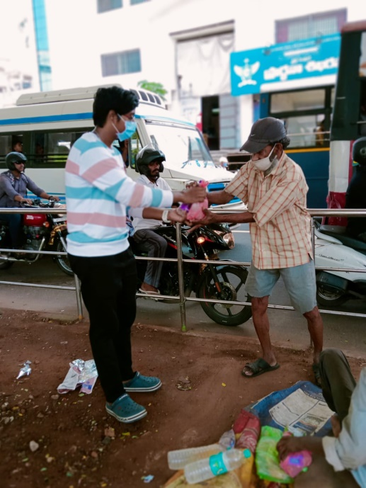

Hence, We fought with this situation also and was very successful and was very thankfull to all our sponsors.

**Our Next step is to educate the poor youth and make them free of anxiety they are feeling in order to do so**

After the situation get improved a litle bit so we organise a event in which we welcome various student to tell them about each and everything and they can iterate that to their parents aat their homes.

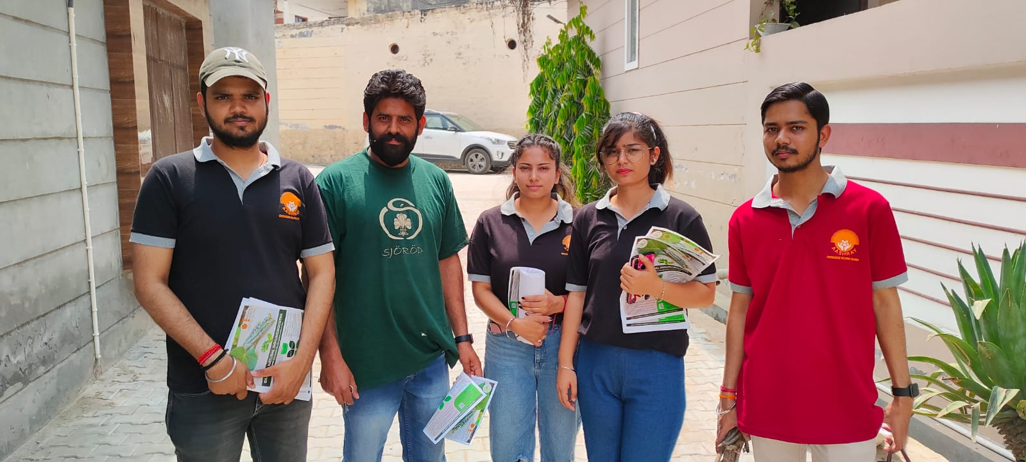

And to prevent anxiety and spread positivity we march upon road and start distributing the sharbats and started various workshop to educate the lower young children in Gov schools.

We also provide gifts and all this is to spread positivity

We start conducting various session after 1st wave:

First meet in Governent school telling students about cleanliness

Little active participation can result in great way

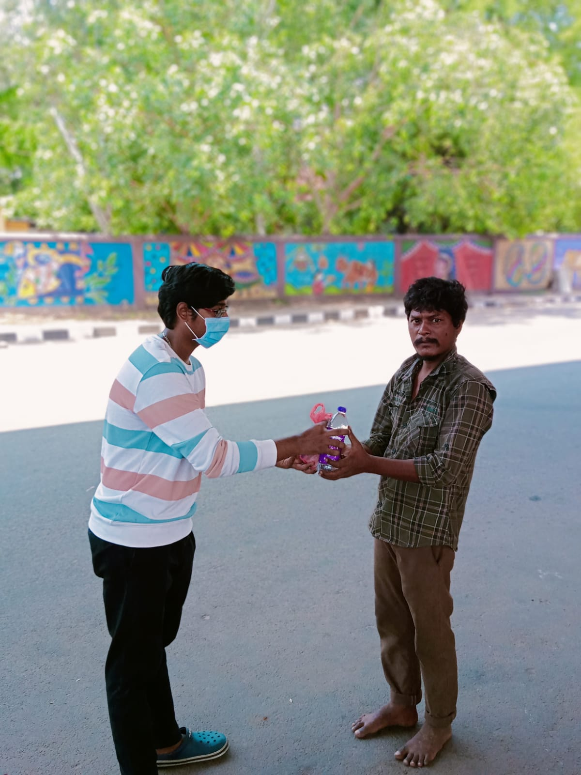

**Our volunteer herself started cleaning the huge field to spread message of cleanliness.**

Next step is encouraging peoples regarding health and helping in order to do so we again started the search of sponsors and thanks to LIONS GROUP jaipur for holding our hand .

We organised various health drives and many blood donation as well as vaccination camp and our volunteer including me take stab of vaccine to show others that it is safe.

Blood donation help in various ways first it will help the needy also it will fulfil the needs of greedy.

Some glimpse of it are:

Blood Donation cap organised under the banner of lions club

**Our Chief Guest**

**MR. Devendra Jhajhadiya para Olympic Winner**

**Enlighten our event with his hands we are very thank full to him also**

**Various Online sessions were held in order to have better communication among our team and to tell each other their work**

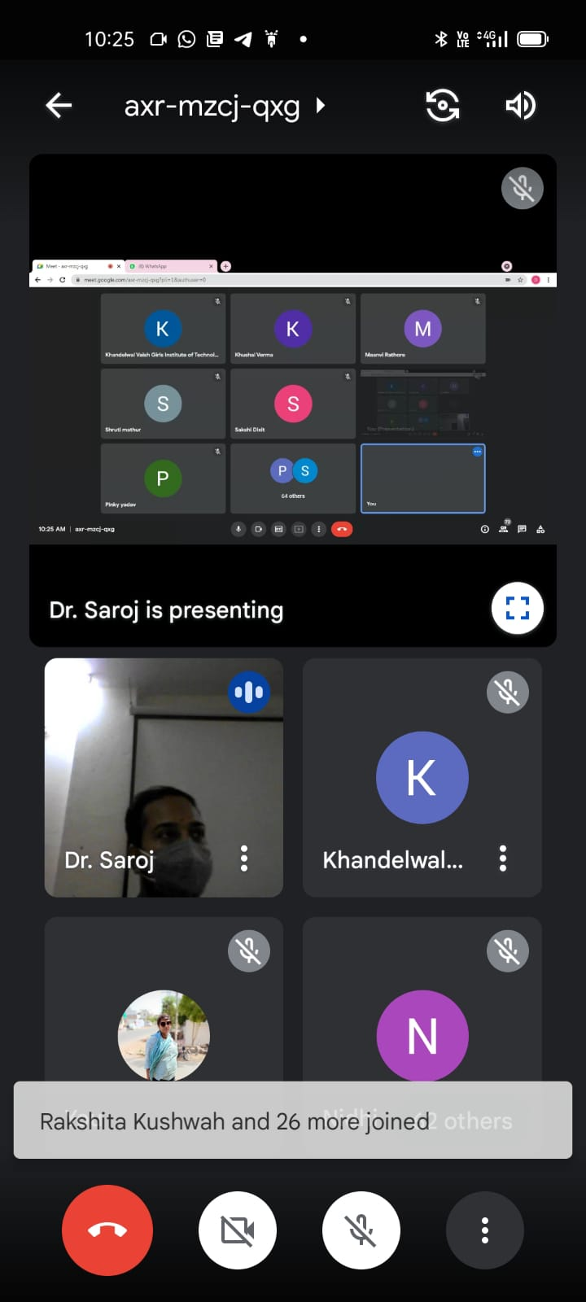 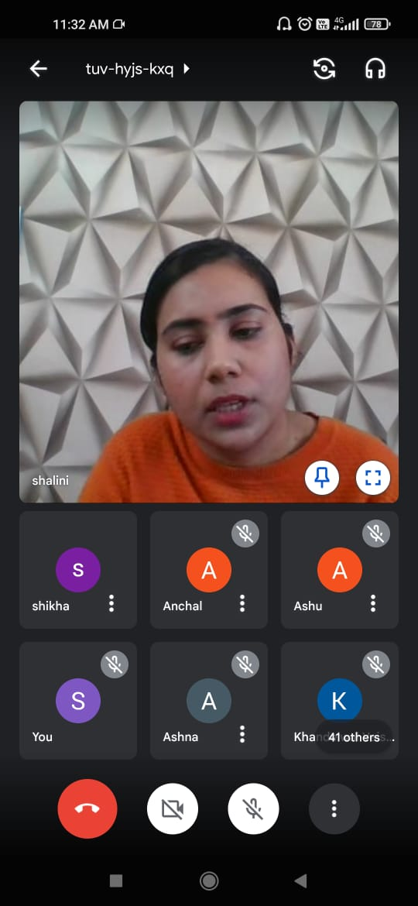

**Also we have invited the local cleaners of our area and welcomed them and honor them with a medal, turban and a small sum of money to encourage them.**

Giving Envelop to all workers.

**We invited both ladies as well as men in order to show gender equality more over to present equality at that moment the president of committee address us.**

**ACTIVITIESDONE**

**Day1: Introduction of Meenakshi shiksha samiti and online meeting with leaders**

**Day 2: Distribution of work ,understanding the work of website to spread awareness. Making report and video editing.**

**Day 3: Started working on website as tech student with my tech team. making report and video**

**Day 4: Continued the work on website along with spreading the awareness of line and making and editing report and video and doing offline work in our community**

**Day 5: distribution book copies and food in continued the work of website and started the search of sponsors and making report and video and raising fund for the projects**

**Day 6: Website completed hosted the website and now working online to help people. I making report and video**

**Day 7:Collected the money from sponsors and started to work on distribution of food by NGO. I making report and video**

**Day 8:Attend all queries on website and distributed food in local area . I making report and video**

**Day 9: Along with distribution of food suggested new ideas for new work. I making report and video**

**Day 10: attended Meeting for new tasks. And doubt clearing session I making report and video**

**Day 11:distributed in different teams and working in the team for educating poor And content writing.**

**Day 12: first meet in gov school to provide appropriate knowledge to students**

**Day 13: making report and content writing**

**Day 14:second meet in another school distributed gifts to motivate students**

**Day 15: Joined health team and worked in organize various health events in my area**

**Day 16: making report and content writing**

**Day 17: Attended blood donation camp in virtual mode and advertise more so that it reaches to more people**

**Day 18: making report on women empowerment and food distribution.**

**Day 19: started spreading the news regarding health among people in online mode**

**Day 20: making report on Animal welfare trust and food distribution and making videos.**

**Day 21: talked various hospital regarding health of people and distributed foods packet**

**Day 22: Editing of report and videos for the organization**

**Day 23: making review of all videos and making report of food and copies distribution**

**Day 24: website work finished and published it**

**Day 25: finding sponsors for the projects**

**Day 26: report making of education system and content writing and video making.**

**Day 27: Convocation for good performing students**

**Day 28: making report and content writing**

**Day 29: making reports of all days and videos.**

**Day 30: giving lots of reviews and quizzes and they give form of volunteer of NGO and all reports summitted and certificate distributed.**

***CHALLENGES***

COVID-19 has created unique challenges for different segments of the population and struck at the very heart of the machinery designed to protect people from such calamities.

The case in point is of social sector- the NGOs and volunteers who are working at the ground level, often even without the basic facilities. Here are some practical issues being faced by them:

* main challenge was to reach the neediest people.... to find out who need it the most, as it was all locked down, travelling, doing survey was not possible. So as to reach the right people was all a challenge.

* Social workers work unarmed in the line of fire: Health workers in India aren’t fully equipped to deal with calamities such as COVID-19.

* Coronavirus has triggered a funding crisis for NGOs when they are needed most

. * The economic downturn means future aid budgets and donations are likely to decline

In this period o 30 days we have enjoyed a lot and learn a lot about each and everything and loves to help others our project was very effective in order to achieve goals that we have decided.

**Effectiveness:**

Our project seems to be very effective in improving the life style of people in the time of need when each and every people want to help but unable due to some reasons

Our each and every decision help to safe million of life’s as the website we make is used to tell people about the availability of beds, ventilators ,vaccines and many more and it will be very useful for the one that need a ventilator urgently .

We have get 1000nd of leads and we try to help all of them more over our NGO has done a great deal to avoid black hoarding they provide each and everyone the oximeters at just rupees 249.One can order it just by sitting at their homes.

Secondly our food distributing mission help needy people because they are not able to get work at that time and was unable to arrange food for their food so our mission aims that no one should sleep hungry and we proved it by distributing the food to more than 5000 people in one month.

Our positivity spreading step was a great step toward eliminating anxiety and setting up a peaceful environment every where .people have appreciated us to do such a kind work.

**CONCLUSION**

Although this section on gender and NGOs in the management and sustainable use of the environment has been only exploratory, it is hoped that it will serve as a basis for further research into the gender and NGO issue, with special reference to women's access to critical resources such as training in farming systems, extension services, land, technology, credit, farming inputs and strategies for wood-fuel management to stem the environmental degradation NGOs and people's organizations, unburdened with large bureaucracies and noted for their flexibility and innovativeness, are often able to implement programmes and activities more effectively.

NGOs are able to respond more quickly to grassroots needs, implement projects at a faster pace and gather feedback sooner than other types of development agencies. In most cases, NGOs are able to muster the necessary skills and expertise needed to carry out pilot programmes and projects and to implement government programmes for social service delivery.

In certain cases, such as in Bangladesh, the scale of operations of some NGOs has gone beyond pilot projects. With small or even non-existent bureaucratic structures, NGOs typically have far lower operating costs than government service delivery mechanisms. The Meenakshi shiksha samiti must be at the forefront of responding to the rapidly escalating humanitarian needs around the Jharkhand – saving lives and so much more, through this pandemic and beyond. And, as with any crisis, there’s opportunity. Opportunity here to design and develop new financing solutions, which could help to find new and better ways to tackle global challenges together.

This has never been more needed than now

The effectiveness of NGO interventions in the development process hinges, to a large extent, on whether or not the policy environment is conducive. Governments which actively welcome NGO involvement and participation in the development process provide a policy environment where NGOs are viewed as partners and not as competitors. NGO activities include, but are not limited to, environmental, social, advocacy and human rights work. They can work to promote social or political change on a broad scale or very locally. NGOs play a critical part in developing society, improving communities, and promoting citizen participation..